Lecture 7

AWS-S3-Calculator-NFS

Interview Questions

S3 classes

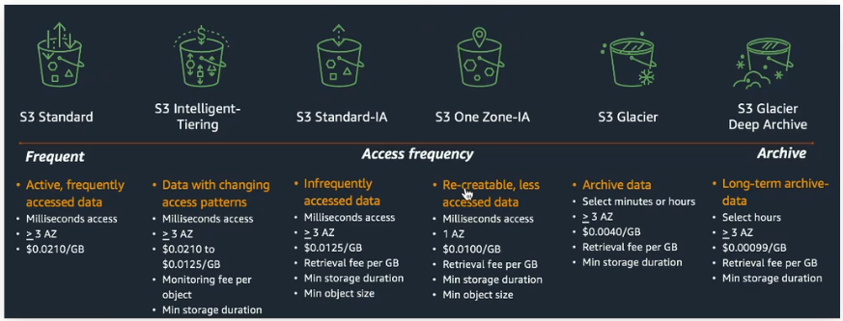

It depends upon requirements which bucket is to be used.

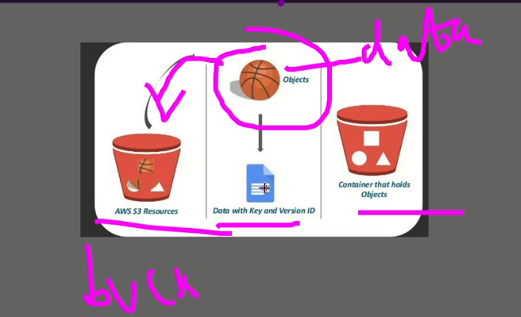

By default in S3 bucket there is not public access.

How to make it public?

Every file has endpoint URL

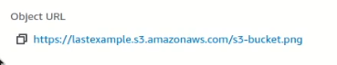

This can be accessed globally.

If we try to open it 🡪 Access denied.

Permissions

.

.

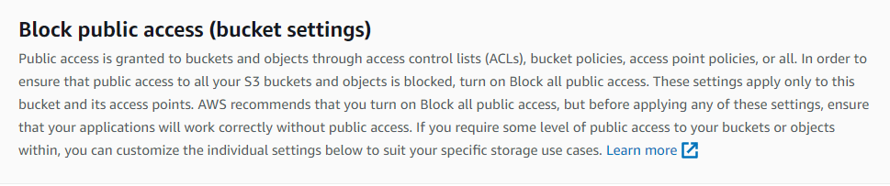

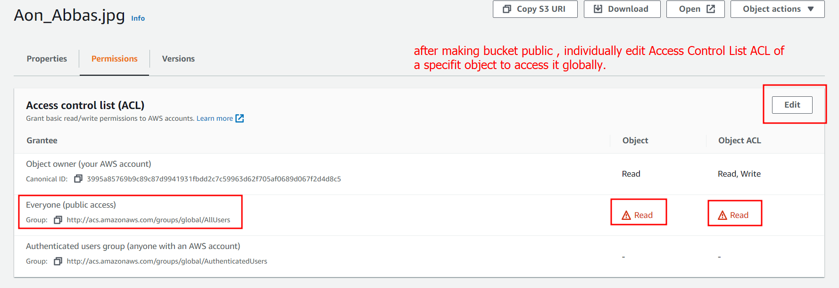. But Sir Kazim used this way which is more professional

.S3 takes charges if a file is shared and accessed for long time.

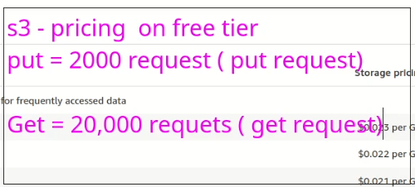

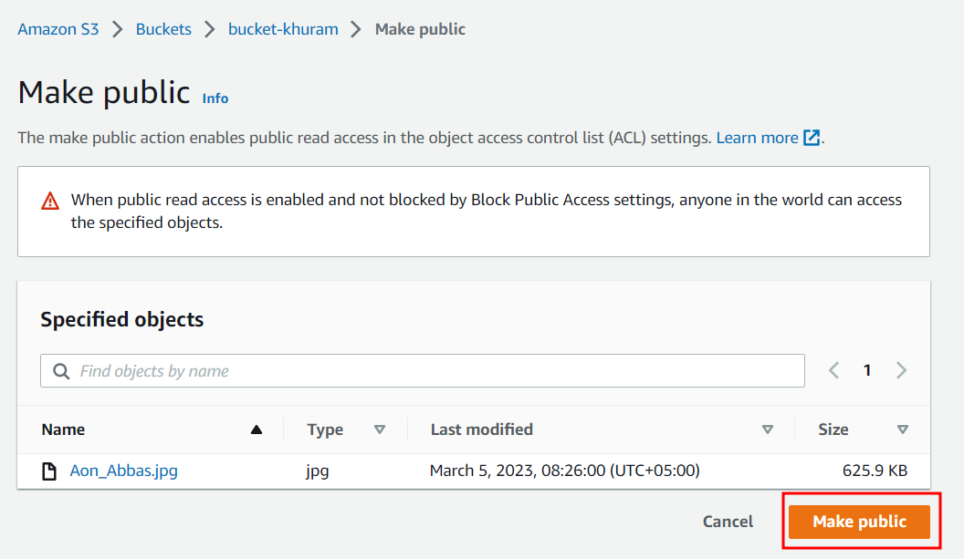

.to change storage classes

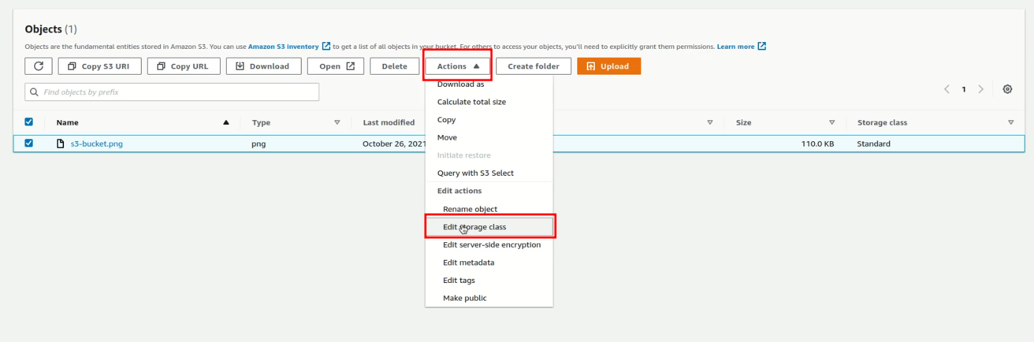

.

The object level data is accessed through an API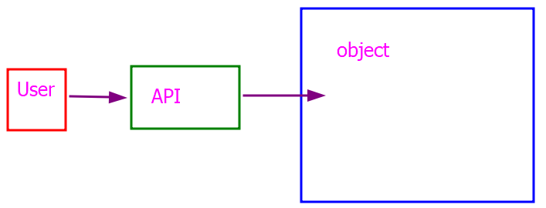

**API** stands for Application Programming Interface. It is a set of protocols, routines, and tools that are used to build software applications. An API specifies how software components should interact with each other and enables different software applications to communicate and share data with each other.

In general, an API can be thought of as a messenger that takes requests from one application, processes them, and returns the response to the requesting application. APIs can be used to retrieve data, perform actions or tasks, or even automate complex workflows.

APIs are used in many different contexts, including web applications, mobile applications, and desktop applications. They can be used to integrate multiple applications, automate tasks, or even build new applications on top of existing services or data.

Examples of popular APIs include the Google Maps API, the Twitter API, and the Amazon Web Services (AWS) API, which provides access to various AWS services such as EC2 (Elastic Compute Cloud) and S3 (Simple Storage Service).

Types of APIs

There are several types of APIs that are commonly used, including:

1. **REST APIs:** REST (Representational State Transfer) APIs are a type of web API that uses HTTP requests to GET, POST, PUT, and DELETE data. They typically use JSON or XML as their data format and are often used for web applications and mobile apps.
2. **SOAP APIs:** SOAP (Simple Object Access Protocol) APIs are a type of web API that uses XML as its data format and typically uses the HTTP or HTTPS protocol. They are often used in enterprise applications to perform complex tasks and transactions.
3. **GraphQL APIs:** GraphQL is a query language for APIs that was developed by Facebook. It allows developers to specify exactly what data they need from an API, reducing the amount of data transferred over the network.
4. **WebSocket APIs:** WebSocket APIs enable real-time communication between a server and a client, allowing data to be sent and received in real-time without the need for continuous HTTP requests.
5. **gRPC APIs:** gRPC is an open-source framework that allows developers to build high-performance APIs that can be used across multiple languages and platforms. It uses Protocol Buffers, a binary serialization format, to transfer data between clients and servers.
6. **OpenAPI/Swagger APIs:** OpenAPI (formerly known as Swagger) is a specification for building REST APIs. It allows developers to define the structure of an API in a standard format, making it easier to document and consume.

Each type of API has its own strengths and weaknesses and is suited to different use cases.

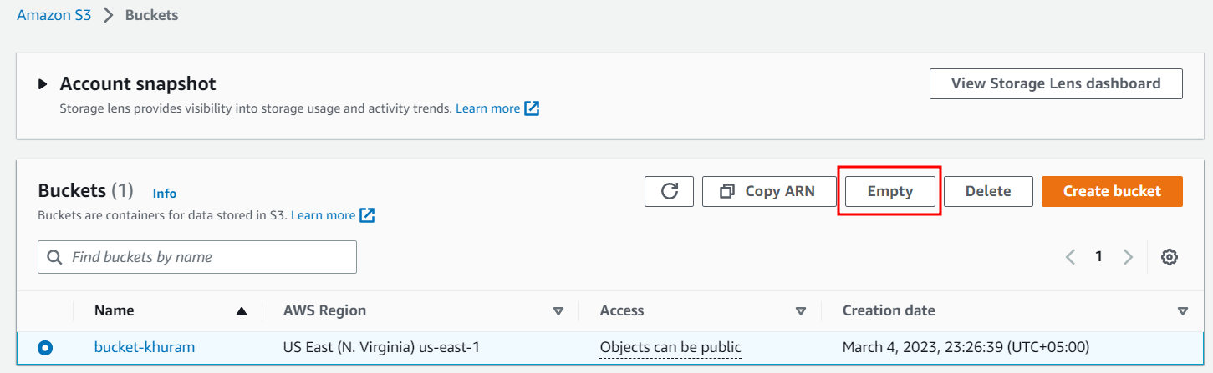

* S3 is global and regions specific.
* EBS is AZ specific.

|  |  |  |
| --- | --- | --- |
| **Region Specific** | **AZ Specific** | **VPC** |
| S3 | EBS |  |
| CloudFront |  |  |
| IAM |  |  |

AWS offers a wide range of services that are designed to meet different business needs. Some of these services are region-specific, availability zone-specific, or VPC-specific.

1. Region-specific services: AWS operates in multiple regions across the world, and some services are only available in specific regions. This is because different regions have different regulations, laws, and infrastructure. Some examples of region-specific services are Amazon S3 Glacier, Amazon SageMaker, and AWS Outposts.
2. Availability zone-specific services: Each region is further divided into availability zones, which are physically separate data centers within the same region. Some AWS services are designed to work within a specific availability zone to provide better fault tolerance and availability. Examples of availability zone-specific services are Amazon RDS and Amazon EC2.
3. VPC-specific services: AWS Virtual Private Cloud (VPC) allows you to create your own private network within the AWS cloud. Some services are designed to work only within a specific VPC, providing additional security and control. Examples of VPC-specific services are Amazon RDS and Amazon EC2.

It's important to note that not all AWS services are region-specific, availability zone-specific, or VPC-specific. Some services are available globally, while others are available across multiple regions. It's also important to check the availability of specific services in your desired region or availability zone before you start using them.

* .
* Globally specific services

Yes, AWS offers several services that are available globally across all AWS regions. These services are designed to be accessible to users worldwide and include:

1. Amazon S3 (Simple Storage Service) - A scalable object storage service designed for storing and retrieving data from anywhere on the web.
2. Amazon CloudFront - A content delivery network (CDN) that provides low-latency and high-speed delivery of data, videos, and applications to users worldwide.
3. Amazon Route 53 - A highly available and scalable DNS (Domain Name System) web service that routes traffic to AWS resources and other internet resources.
4. Amazon SNS (Simple Notification Service) - A messaging service that allows you to send notifications and alerts to multiple recipients, such as email, SMS, and mobile push notifications.
5. AWS IAM (Identity and Access Management) - A web service that helps you control access to AWS resources by creating and managing users, groups, and permissions.
6. AWS CloudTrail - A service that provides governance, compliance, operational auditing, and risk auditing of your AWS account.
7. AWS CloudFormation - A service that allows you to create and manage AWS resources using templates.

These are just a few examples of AWS services that are available globally. It's important to note that some features within these services may not be available in every region, so it's always a good idea to check the AWS documentation for more information.

* .
* Next topic
* CentOS 2 VMs
* Server Client Model
* 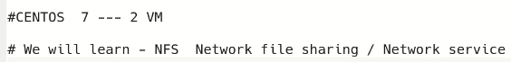
* 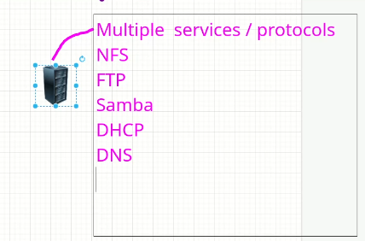
* It is possible to run all these services on one system because every service has a unique “port”.
* But industry stands is to use separate/segregated systems for each service.
* 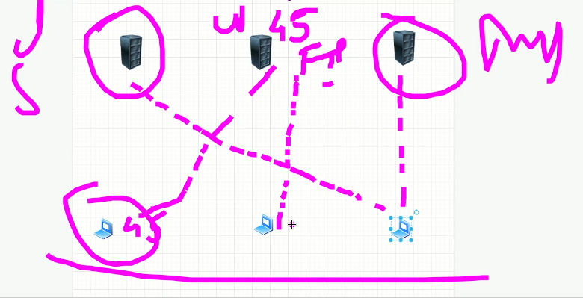
* Client uses particular service on specific server
* Clustering
* 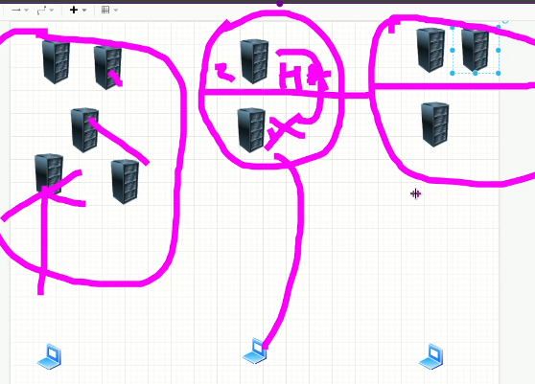
* Each sever has clusters of servers in case of failure and it is called “High Availability”. Or failover

NFS 🡪 Network File Sharing or Network File Service

* In AWS its alternative is EFS
* Working of NFS is same as NAS (Network Attached Storage)
* Network-Attached Storage: This is a type of data storage that is connected to a computer network and provides file-level access to multiple clients. NAS devices typically use file-based protocols such as NFS or SMB/CIFS and can be accessed by multiple users at the same time.
* Port 2049
* Works on UDP Protocol
* Linux to Linux sharing
* Doesn’t ask to username & password (drawback)

Samba 🡪 file service

* + Port No. 137, 139, 335
  + Uses TCP Protocol
  + Linux to Linux or Linux to Windows
  + Requires Username & Password
  + Server CentOS 7 VM
  + Client CentOS 6 VM
* Server Configuration
  + Tasks 🡪 share a folder over network,
    - Steps
    - 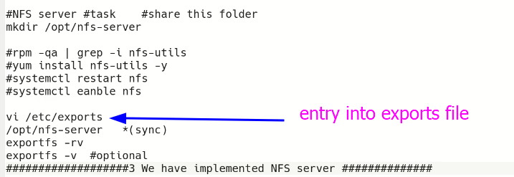
    - 1 to 2 minutes time is required in Linux. 🡪 but in production environment ask for 1 to 2 days for complete setup and trouble shooting.